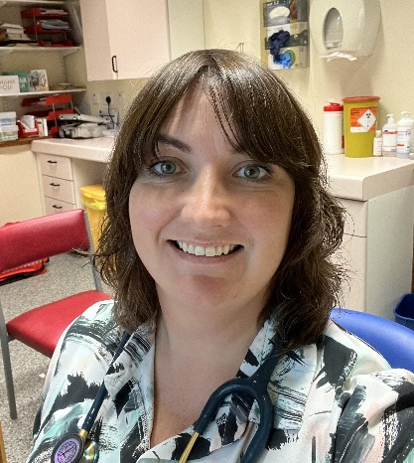
Meet Laura: She is an NHS pharmacist with a specialist interest in respiratory who is working in our surgery on Wednesdays. She will be doing a Quality Improvement Study in Helmsdale and Brora to ensure patients are prescribed the right inhaler for them. All patients on the asthma register will be called for a review in due course but we are inviting people who would like to be reviewed sooner to get in touch.
Why do you want to see our patients?
“Uncontrolled asthma can result in unnecessary hospital admissions and avoidable deaths. These outcomes are preventable through improved asthma control but I often see people on the wrong types of inhalers, or patients who aren’t using their inhalers correctly through no fault of their own.
Getting the right inhaler for patients can be tricky because there are so many to choose from and each one is different. Matching the inhaler device to the needs of the patient is critical to successful long-term management of conditions like asthma. I like to work alongside the clinicians to complement their consultations: I can take time with the patients to ensure the medication they selected is delivered in the most effective way so that patients can gain the most benefit from their medications.
I also want to educate patients around the waste associated with inhalers and their impact on climate change and what we can all do to help.”
Did you know?
Using your reliever (blue) inhaler more than three times a week is a sign of poor asthma control
Your asthma symptoms can change over time
Your asthma symptoms should not impact your daily activities
Your inhaler can have a big impact on your carbon footprint
People with asthma can avoid bothersome or life-threatening asthma symptoms if they are prescribed the right inhalers and use them in the right way

